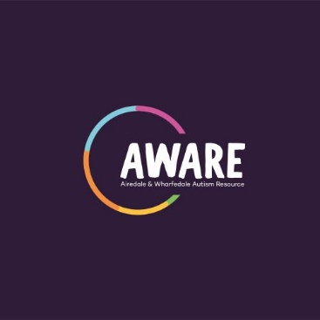

AWARE (Airedale and Wharfedale Autism Resource) Parent Information Event (PIE)
Tuesday 10th November 2020 at 9.30am until 11.00 am via Zoom

As parents of children and young people with autism, the AWARE team really want to help and support you and your family on your journey, whether your child/young person has just received a diagnosis, has recently been added to the pathway for an autism assessment, is struggling to get a diagnosis or has received a diagnosis of autistic traits or another condition. One of the first things our families want to know is: where do I start?
We shall be hosting our next PIE (Parent Information Event) online via the Zoom platform on Tuesday 10th November 2020 between 9.30am and 11.30 am.
We have previously held these free events at venues within the centre of Bradford and in Bingley/Keighley for newly diagnosed families. Obviously, due to COVID, we are unable to hold large face-to-face events at present, so we are intending to host this event online for the first time, opening up the PIE to include ANY families who may still be on the autism assessment pathway as well as those whose child/young person has recently received a diagnosis of autism.
We are hoping that the PIE will be a ‘one-stop shop’ for all information relating to services available within the Bradford district, to help families on their autism journey find out what support is available within the Bradford and Airedale area. We will talk about AWARE and the services we provide as well as having professionals attend from a variety of services including Bradford and Airedale Speech and Language; Bradford Local Offer; Social, Communication, Interaction and Learning Team 0-25 Specialist Teaching and Support Services (SCIL - Bradford Education); Social Care and other support groups to provide information about the services they provide for the families. This information will be presented either in person on Zoom, or by video to the families attending. The families will also be able to sign up to training courses available.
Places MUST be booked in advance for this event and will be limited. If you or a family you are working with would like to attend, could you please get them to email Nikki Pickles at nikkipicklesaware@gmail.com
We will then send further information and full instructions as to how to join the session.
Looking forward to hearing from you!
The AWARE team.

