`

School Nursing Special Needs- Information for Special Schools

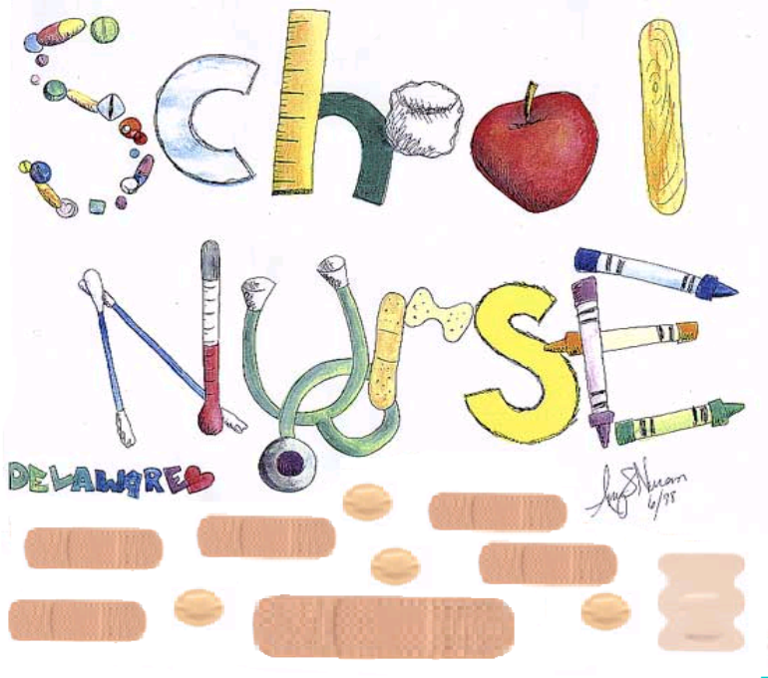

School Nursing Special Needs Team

Westbourne Green Community Health Centre

50 Heaton Road Bradford BD8 8RA

**01274 221 203**

[**snsn@bdct.nhs.uk**](mailto:snsn@bdct.nhs.uk)

**INTRODUCTION**

This booklet aims to inform special schools and all staff about the School Nursing Special Needs Service and what you can expect from the nursing team.

We are a developing service and are committed to working with schools to support children with Special Educational and complex health needs to access school, achieve positive experiences, and reduce health inequalities. We are a specialist service team for children attending special schools. We provide support to children and young people with disabilities and / or complex health needs to access and achieve their optimal learning potential within a school environment from the age of 4-19 years of age. To be on our caseload the child or young person must have an EHCP and be enrolled at a special school in the Bradford District.

We are very proud of our team, our schools and our Children and young people and strive to provide a service that meet their needs and is of high quality. We are committed to development and are happy to receive any suggestions that will help to shape our service delivery.

**OUR SNSN SERVICE VISION**

We would like to share our team vision- we collaborated and agreed on this and think it captures what the SNSN service strives to achieve.

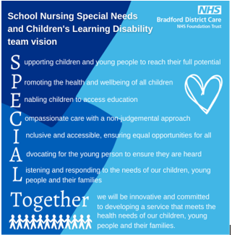

**The Special Needs School Nursing Team (SNSN)**

**Hayley Smith** – Clinical Manager for SNSN team and Childrens Learning Disability Team Craven

**Email**: hayley.smith@bcdt.nhs.uk

**Megan Speak** – Team Leader of SNSN team and Childrens Learning Disability Team Craven

**Email**: megan.speak@bcdt.nhs.uk

**Jane Pitchfork**- Clinical Lead

**Email**: jane.pitchfork@bcdt.nhs.uk

**Emily Hosker**-Team Facilitator

**Email**: emily.hosker@bcdt.nhs.uk



**Louise Picken** -Team Administrator

**Email**: louise.picken@bcdt.nhs.uk

|  |  |
| --- | --- |
| **Chellow Heights Special School**  **Chellow Heights (West)** Thorn Lane, Bradford, BD9 6AL.  Named Nurses are:  **Nicola East** and **Sarah Mortimer**. |  |
| **Chellow Heights (South)** Netherlands Avenue, Bradford, BD6 1EA.  Named nurse is:  **Caroline Kershaw** |  |
| **Brooklands school**. Burnside Ave, Skipton, BD23 2DB.  Named nurse is:  **Lindsay Beaumont** |  |
| **Hazelbeck Special School** Wagon Lane, Bingley, BD16 1EE.  The Named Nurse is:  **Anniya Mohammed** |  |
| **High Park School** Thorn Lane, Bradford, BD9 6RY  Named Nurse is:  **Hazel Capstick** |  |
|  |  |
| **Beckfoot Phoenix Special School Braithwaite** Ave, Keighley, BD22 6HZ.  Named Nurses are:  **Liz Lyles** and **Nakita Moran** |  |
| **Beechcliffe Special School** Greenhead Rd, Keighley, BD22 6ED.  Named Nurses are:  **Amna Khan** and **Nakita Moran** |  |
| **Delius Special School** Barkerend Rd, Bradford, BD3 8QX.  **Delius satellite school** Willowfield Street, Bradford, BD7 2AH  Named Nurse is:  **Eloise Ainge** |  |
| **Southfield Special School** Haycliffe Lane, Bradford, BD5 9ET.  Named Nurses are:  **Vannessa Baxter, Carmel Frahill and Sarah Mortimer** |  |
| **Beechcliffe Thackley** Ellar Carr Road, Bradford, BD10 OTD.  **Oastlers School** Flockton Road, Bradford, BD4 7RH.  **Keighley satellite school (Oastlers Keighley)** Exley Road, BD21 1LT,  Named Nurses are:  Specialist nurse **Sian Powell** ( SCPHN.)  **Sarah Knight** (Staff nurse)  **Ellie Rhodes- Burke** (Health Care Support Worker) |  |
| **Janet Robertshaw** – Clinical Lead Practitioner (for Beckfoot Academy Trust)  **Jess Green** – Healthcare Support worker (for Beckfoot Academy Trust) |  |

|  |  |
| --- | --- |
| **SNSN Health care support Team** | **Working across all special schools** |
| A picture containing person, outdoor  Description automatically generated Alison De Lima | A person wearing glasses  Description automatically generated with medium confidence Jayne Bailey |
| A person smiling for the camera  Description automatically generatedJannette Egan | A person wearing a black head scarf  Description automatically generated Saima Ansar |
| A person with glasses smiling  Description automatically generated Andrea Naylor | A picture containing person, wall, posing  Description automatically generatedRosie Brockett |
| Emma McDonald |  |

**OUR SNSN SERVICE OFFER**

Our service works in line with a service specification which is agreed with our commissioning bodies at the Integrated Care Board. Through this we are bound to deliver and achieve specific service delivery. We are continuously developing our service in a bid to provide optimum support and reduce health inequalities.

Our core offer to our special schools, children and young people is currently: As a school nursing service, working alongside our service specification, we also consider preventative and public health needs of children. The Healthy Child Programme (2009) highlights how all children should be offered support to achieve their full potential, enjoying the same opportunities as their peers both in and outside school The HCP recommends a core service offer which we adapt to enable us to meet the needs of our children with SEND and complex health needs. Therefore, all children attending special schools are offered:

* Reception Screening- Height and weight measurements and audio ( hearing) screening
* Year 6- Height and weight check
* Yr 8- Childhood immunisations (Human Papillomavirus)
* Yr 9- Childhood immunisations (Diphtheria, Tetanus, Polio and Men C)

Other important elements of service delivery are:

* Initial health needs assessment, prior to school entry, for all children with an EHCP to identify specific intervention and support that may be required.
* Development of care plans for specific health/ medical needs for children and young people, and support school and short breaks staff to implement them.
* Work collaboratively to support the physical, emotional and social needs of the children and young people with other professionals such as; Pediatricians, Speech and Language services (SALT), Dieticians, Physiotherapists, Child and adolescent mental health services (CAMHS), Social Care, Barnardo’s and the Local Authority.
* The School Nursing Special Needs Team have an active role in the statutory safeguarding processes, recognising the vulnerability of the children and young people we work with and being able to respond appropriately, working towards, in line with policy to provide a positive contribution to the safeguarding process.
* Provide health information for EHCPs (Education Health Care Plans)
* Provide a health promotion programme within schools. This includes immunisation programmes, desensitisation work, heights and weights and drop-in sessions for pupils, parents and staff, toilet training workshops for parents with drop-in sessions for support and healthy eating roadshows
* The School Nursing Special Needs Team plan and deliver a specialist training programme to education school staff to meet the health needs of children and young people with learning disabilities and/or complex health needs. This training is also delivered to other services that care for the children and young people who attend a short break setting Wedgewood House.
* Provide a duty service throughout service hours for parents or carers to be able to speak with a member of the SNSN team and offer support with the ever-changing needs of their child and provide appropriate health advice/support or signposting.
* Accept referrals from parents for the request of individualised support for a number of health-related subjects such as continence/toileting issues, health lifestyle, behaviors, difficulties with accessing other health services, behaviors, emotional/mental health support.

**SNSN SERVICE DELIVERY PLANNER**

This planner demonstrates the yearly work commitment and when this is delivered across the year. As a school, you can expect that the named staff from the SNSN service would make contact to arrange activity within your school at the times allocated on the year planner:

|  |  |  |  |  |  |  |  |  |  |  |  |  |  |  |  |  |  |
| --- | --- | --- | --- | --- | --- | --- | --- | --- | --- | --- | --- | --- | --- | --- | --- | --- | --- |
|  | **JAN** | **FEB** | | **MAR** | | **APR** | | **MAY** | **JUN** | **JUL** | **AUG** | **SEP** | | **OCT** | | **NOV** | **DEC** |
| **Meetings with School Care Teams** | End of Jan- Planning Meeting |  | |  | |  | |  |  |  |  | Planning meeting with Care Teams | |  | |  |  |
| **TRAINING – NEW STAFF** |  |  | |  | |  | |  |  |  |  | Training – New Staff (band 5 except enteral feeding) | | | |  |  |
| **TRAINING – REVIEWS** |  | Training – Annual updates (band 5 except enteral feeding) | | | | | | |  |  |  |  | |  | |  |  |
| **Audiology/Height and Weights Screening (Reception)** |  |  | | Desensitisation to Audiology | | Audiology heights and weights for Reception | | |  |  |  |  | |  | |  |  |
| **Weights for school leavers** |  | Heights and weights year 6 and year 13/14 | | | | | | |  |  |  |  | |  | |  |  |
| **HEALTH PROMOTION** | Healthy  Eating |  |  |  | | Sun Safety | |  | Accident Prevention |  |  | Hand Washing | | | |  |  |
| **IMMUNISATION PREPARATION\*** |  |  | |  | |  | |  |  |  |  |  | Whole School Immunisation Preparation | | | | |
| **Toileting workshops – One per term.** |  | Spring term | |  | |  | |  | Summer term |  |  |  | |  | | Autumn term |  |
| **Termly parent/ child Drop in.** |  | Spring term | |  | |  | |  | Summer term |  |  |  | |  | | Autumn term |  |
| **EHCP Process** |  |  | |  | |  | |  |  |  |  | EHCP List for the new school year | |  | |  |  |
| **INITIAL HEALTH NEEDS ASSESSMENTS FOR NEW STARTERS ɫ** |  |  | |  | | Initial Health Needs Assessments | | | | | |  | |  | |  |  |
| **VACCINATIONS:** |  |  | |  | |  | |  |  |  |  |  | |  | |  |  |
| **Influenza**  **(Whole school)** |  |  | |  | |  | |  |  |  |  |  | | Flu vaccination | | | |
| **School leaver booster (Yr 9) boosters (DipTet, Polio, Men ACWY)** |  |  | School leaver Booster vaccination | | | | Catch up Clincs |  |  |  | Catch up Clinics |  | |  | |  |  |
| **HPV**  **(Year 8)** | HPV Vaccine |  | |  | | | |  |  |  | Catch up clinics |  |  | |  |  |  |
| **MMR** |  |  | |  | MMR vaccination | | |  |  |  |  |  | |  | |  |  |

**REFERRALS INTO SNSN SERVICE**

The School Nursing Special Needs Team usually become aware of a young person starting or moving into a special school through handover from another health professional ie Health Visitor or out of area School Nurse. Schools are also informed of New Starters via the Local Authority who will also inform The School Nursing Special Needs Team. To prepare for them starting school these children automatically become part of The School Nursing Special Needs Team caseload with their health record being reviewed, an initial health assessment carried out with parents/ carers and relevant care planning and preparation for school entry taking place.

There may be times throughout school that additional support is required for a child for a variety of health reasons. You may raise your own concerns or those of a parent or carer on their behalf (with their consent).

The School Nursing Special Needs Team can support with additional health needs and this can be referred to us via our referral pathway:

********

Once we have received your referral, the designated Team Facilitator will review the request and allocate this to the most appropriate staff member. The staff member will assess if the referral is appropriate for The School Nursing Special Needs Team and then work with the child/ parents or school, to resolve the issue. This may be further assessment, advice and support for the family, signposting or referral to other specialist services or the provision of extra training for school staff. With parent’s consent, any actions or outcomes will be fed back to the referrer. We aim to respond to all referrals within 4 weeks of receiving them.

**TRAINING OFFER IN SCHOOLS**

The School Nursing Special Needs Team have a pivotal role in providing specialist training to education staff to enable staff to meet the health needs of pupils attending their school, safely, and in line with policy. Training will be carried out in each school by both nurses and health care support workers.

In September of each year, the nursing team will arrange to meet with the care team in school to agree and arrange the training offer across the school year, depending on needs of the school. The sessions will be planned for your school staff and to fit around other service delivery commitments. We therefore require the school to have a good understanding of the training requirements for their staff and to be able to plan accordingly for the year ahead.

Further information can be found in the **SNSN Training Offer for Special Schools document (supplied to school).**

**INCIDENT REPORTING**

Occasionally health related incidents occur in schools. We request that any incidents are reported to The School Nursing Special Needs Team, either through your named nurse or by contacting the SNSN team directly. By being informed of incidents we can assess if there is a further training need in school and ensure high levels of care, and safe practice are maintained.



Incidents to report to The School Nursing Special Needs Team include but is not limited to:

* Whenever an ambulance is called to school
* If there is a medication related incident/ error
* If there are issues around enteral feeding such as missed feeds, unclear feed plans, errors in administering feeds.
* If a parent has expressed a health concern about their child and has consented for you to share information with the nurse

**Social Media**

Our Team currently have presence on 3 social media platforms (Facebook, Instagram & Twitter). The aim of these platforms are to reach children, parents and other key agencies, to promote our service, other key services and offer valuable health promotion and advice in regards to health and special educational needs. We also showcase and celebrate our team contributions and successes. Our aspiration is to develop our social media offer further by engaging with other platforms and obtaining service user involvement to help plan and improve the quality of information that we share.

**Friends and Family Feedback**

*What is FFT???*  
The NHS Friends and Family Test (FFT) was created to help service providers and commissioners understand whether patients are happy with the service provided, or where improvements are needed. It's a quick and anonymous way to give your views after receiving NHS care, treatment or service.  
More information can be found here:  
  
<https://m.youtube.com/watch?v=fGGgRtehV2o>   
  
Or an easy read version:  
  
<https://m.youtube.com/watch?v=SgCaM05dUr0&feature=youtu.be>

Encouraging service user involvement and gathering patient experience information is essential and beneficial to all, in the provision, development and co-design of high-quality services. In addition to receiving feedback from service users, it is important to be able to collect feedback from our schools to ensure we are working well and meeting expectations. It would be really helpful, if you were able to provide some feedback by completing the short survey:  
  
To access the survey please click on the link:    
  
New FFT and qr codes to be inserted when we get them

The School Nursing Special Needs Team are collecting Friends and Family Feedback and would love to hear from you.

**COMPLIMENTS AND COMPLAINTS**

We always like to hear positive feedback about our service but also are realistic in knowing that sometimes we don’t get everything right.

The Trust is committed to patient centered care and continuous service improvement. Complaints and compliments about services form part of that valuable source of information to support this. The experiences of patients and service users, their carers and others with a direct interest in service user care are a valuable source of feedback to support continuous improvement. Sometimes things do go wrong and when they do, service users have every right to comment, raise a concern or make a complaint, have it considered and receive a response from the NHS organisation concerned. Many informal complaints, concerns, comments made or raised on behalf of our patients can be effectively dealt with on the spot by staff, managers and the Patient Advice and Complaints department. Where this is not possible, or by the person’s request, patients, carers or their relatives are able to access the formal complaints procedure.

If you have a concern that cannot be resolved in the first instance by speaking with the named nurse for your school, you can contact:

**Megan Speak (Team Leader)** megan.speak@bdct.nhs.uk

**Hayley Smith (Clinical Manager)** [hayley.smith@bdct.nhs.uk](mailto:hayley.smith@bdct.nhs.uk)

If senior management are unable to resolve your complaint to your satisfaction, they will advise you about the process for raising a formal complaint.

**CONTACT DETAILS**

The SNSN team are an all year round service and available Monday to Friday 8am-5pm (excluding bank holidays). There are various ways to contact us:

**Email:** snsn@bdct.nhs.uk **(For Professional Use Only)**

**Tel:** 01274 221203 – this is the single point of access where you can leave a message for the team who will call you back. **(For Professional and Parent Use)**

**Website**: School Nursing Special Needs – BDCT

**School Nursing Special Needs Team Referral Form**

|  |  |  |  |  |
| --- | --- | --- | --- | --- |
| **Child’s Name:** | **NHS Number: (for SNSN use only)** | | | **D.O.B.:** |
| **Child’s School:** | | | **Class name:** | |
| **Contact number for parents/carers:** | **Ethnicity:**  **Is an interpreter required? Yes / No**  **If yes, which language** | | | |
| **Please confirm that you have discussed this referral with a parent/guardian with parental responsibility: Yes / No**  **Have you obtained parent/carer consent to share information with the SNSN team?**  **Yes / No** | | | | |
| **Reason for referral:** | | | | |
| **Outside agencies involved with student/family and contact details of relevant parties:**  **CAMHS □ Social Services □ YOT □ Police □ Early Help □**  **CP □ CIC □ Other** (Please specify) | | | | |
| **Current school action** (briefly, what have you already put in place to support the child?) | | | | |
| **Name of referrer:**  **Email:** | | **Contact number:**  **Date of referral:** | | |
| **Referral outcome:** (For SNSN use) | | | | |
| **Name of SNSN staff:**  **Signature:** | | **Date:** | | |