**Welcome to Hazelbeck School**

**We start school in September**

**We come to school on**

**My Classroom is Purple Base**

**My Teacher is Corrina**

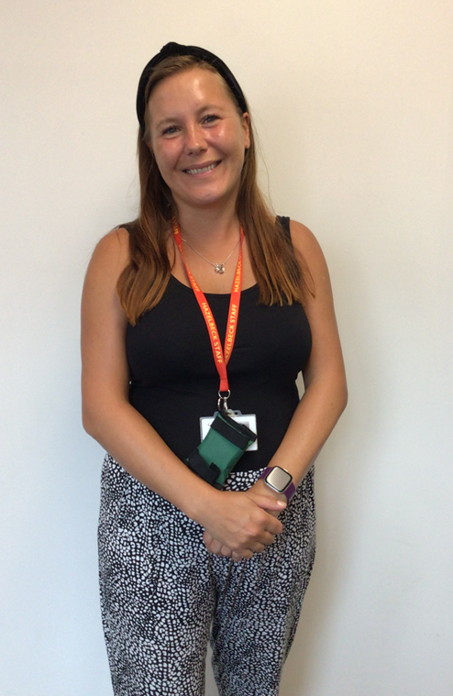

**My Class staff are**

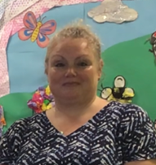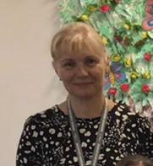

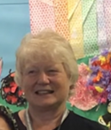

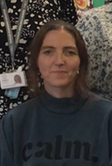

**Urszula**

**Karol**

**Jo**

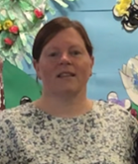

**Louise HLTA**

**Tammy**

**Lauren**

**Helen**

**Abi**

**Robina**

**Places I can use in school are…**

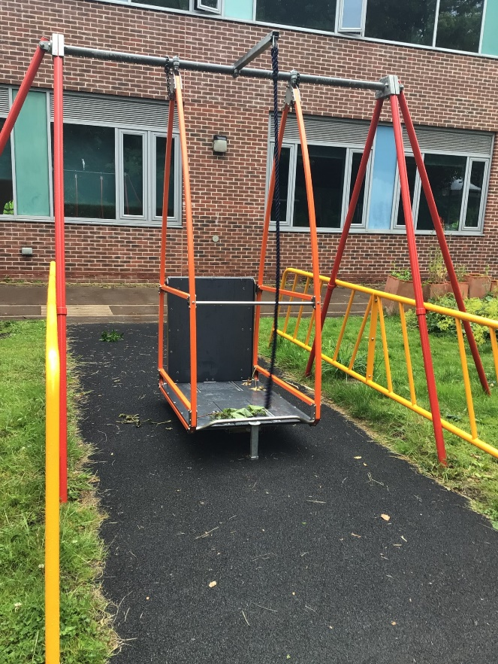

**SWIMMING REBOUND**

**HALL SENSORY GARDEN WHEELCHAIR SWING**

**When School has finished, I will go home**

**Have an amazing Holiday we can’t wait to see you in September!!**

