**Yellow base – Key Stage 3**

Staff

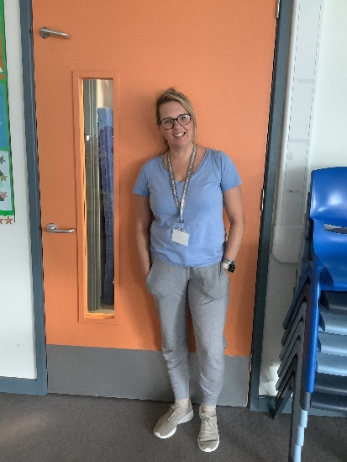 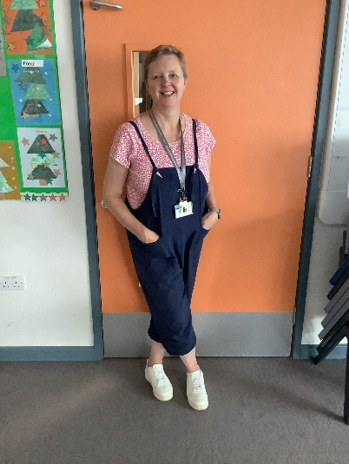 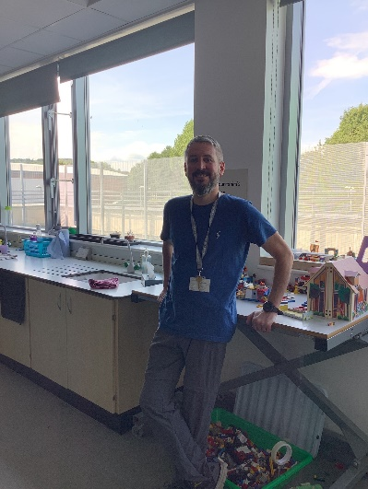

Emma – Teacher Sam – Higher Level TA David - Special Needs TA

Emily – Special Needs Teaching Assistant

Amina - Special Needs Teaching Assistant (Mon, Thu)

Students

Oliver

Eryn

Aidan

Yahya

Matthew

Hashim

Chloe

Sahil

Oscar

Sam

Esme

We are a Key Stage 3 base of 11 students in Hazelbeck Orange Area. We are aged between 11 and 14 all of whom have learning disabilities. We have swimming on Thursdays so all students will need kit and a towel.

We can’t wait to see you all in September.

Yellow base